**INTRODUCTION**

This report is about the pets that are licensed in Seattle. This project may be interesting to the people that are pet loving and would like to explore more about the pets that live at Seattle. This would result in more number of pets being licensed and thus keeping track of the pets accurately. In fact, the readers will get sure that the dogs are more popular or the cats. Also we can see how the breeds can classfy the cats and dogs.

**DATA**

Data was collected from the Kaggle free data sets (<https://www.kaggle.com/aaronschlegel/seattle-pet-licenses/data>). Many other sites like Google, Kaggle, Github and etc provide the free datasets for Data science and machine learning purposes. This data shows all the pets that were licensed. It has columns like animal name, breed- primary and secondary, license number and date, species- Dog or Cat and the pin code where the pet was licensed.

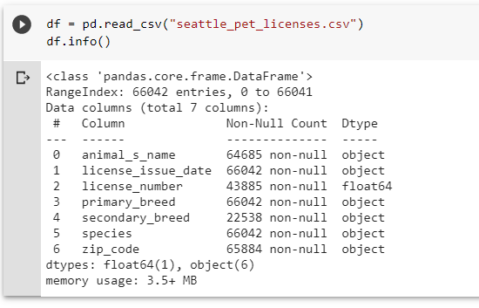

**METHODOLOGY**

The dataset was uploaded to Google Colab notebook and then each column was preprocessed.

First of all the missing values rows were deleted so that we get accurate machine learning model. Then using LabelEncoders the data was manipulated and made ready for the model to be trained.

Three machine learning models have been used-

* Decision Tree 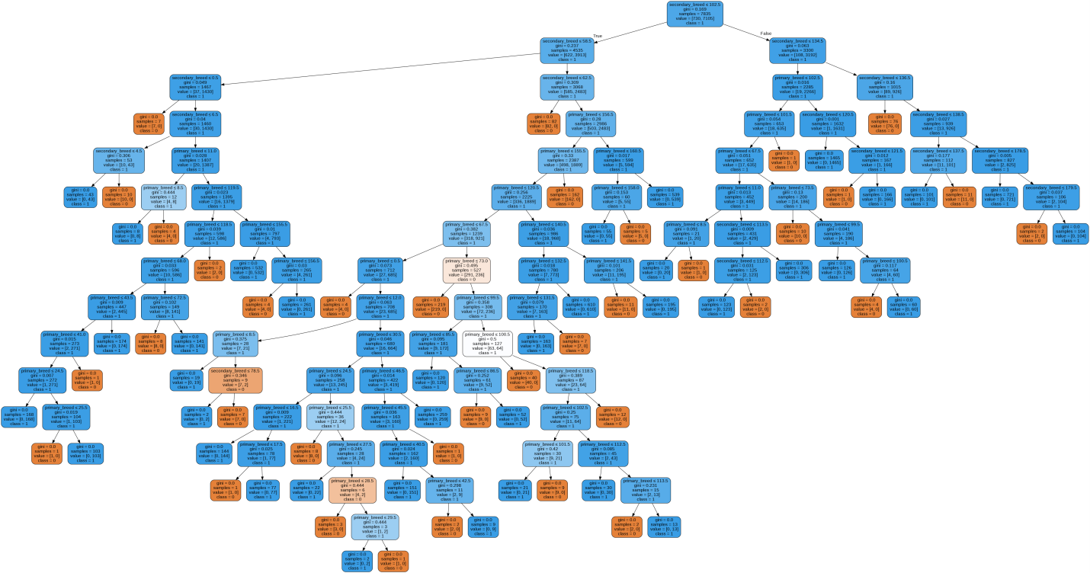
* Random Forest Classifier

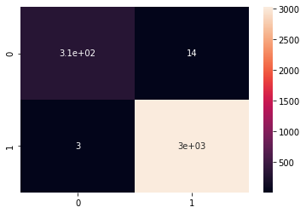

Confusion matrix

* KNN classifier

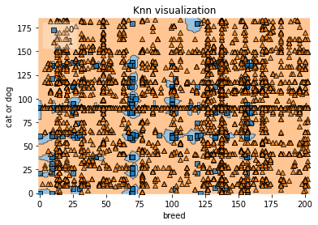

All of them gave an accuracy of 99%.

Thus we classified the species (cat or dog) on basis of breed (primary and secondary) by an accuracy of 99%.

**RESULTS**

We classified cats or dogs based on the primary and secondary breed. Also we were able to find the number of dogs and cats registered for license in a particular area.

Machine learning models helped a lot in classification. All have an accuracy of 99%

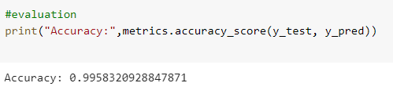

**DISCUSSION**

Following were observed while analyzing the data:

* **Thus there are 109 Cats in area having zip code 98115 and 925 dogs. Thus dogs are more popular in the area where licensed registrations are the highest. and total of 10,253 dogs are registered and 1049 cats**
* Lucy is most popular name for pets Charlie is 2nd most popular, followed by Bella
* 01ST NOVEMBER 2016 records the highest number of registration - 103 followed by 18th OCTOBER 2016 -95
* Duplicate rows have been deleted. Now the pets having same license number are the renewed license. Thus repeating.
* 204 types of primary breed pets have been licensed.

**CONCLUSION**

Now based on the pin code you can know that what types of pets are more in your neighborhood. Also using the machine learning models we could 99% accurately classified the cats and dogs based on the breed type.

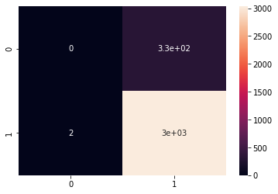

This is the confusion matrix for the prediction of pets’ species for a particular zip code.